
Mini Project Report

Dynamic Spatial–Temporal Graph Transformer
for EEG-Based Valence–Arousal Emotion Recognition on the DEAP Dataset
Course: ICE478
Course Title: Machine Learning
Section: 06
Group: 09
Course Instructor: Dr. Raihan Ul Islam

Team Members:
Name | ID
Tahsina Tabassum | 2023-1-50-002
Saima Akter Tisha | 2022-3-50-018
Fariya Ahmed Bhuiyan | 2022-3-50-009
Iftekhar Alam | 2019-2-57-039

Abstract
This report extends the group's EEG-based valence/arousal recognition system with a dedicated explainability analysis. The underlying pipeline and model are unchanged from the earlier iteration: 32-channel EEG windows from the DEAP dataset are represented in a raw time-domain branch and a five-band spectral-power branch, fused per electrode, and passed through a dynamic, spatially-biased electrode graph (the Time-Efficient Dynamic Spatial-Temporal Graph Transformer, TEDSTGT) before separate binary valence and arousal classification heads. The contribution of this notebook is a four-part explainability suite: (1) aggregated electrode-attention and learned-graph visualizations over the full test set, rendered both as bar charts and as scalp topographies; (2) Integrated Gradients (IG) attributions, decomposing predictions into per-electrode and per-frequency-band contributions; (3) permutation importance, a model-agnostic check of how much balanced accuracy actually drops when a given electrode's signal is destroyed; and (4) a quantitative faithfulness test that correlates the attention map with permutation importance via Spearman's rho. Applied to a model that reaches 76.4% valence and 74.3% arousal test accuracy but only 0.554 and 0.506 ROC-AUC respectively, the explainability suite does more than decorate these numbers with pictures: it actively demonstrates that the model has not learned electrode- or band-specific discriminative features. Permutation importance shows that shuffling any single electrode changes balanced accuracy by at most a few hundredths of a percentage point, IG attributions are visually near-identical across true classes, and the correlation between attention and permutation importance is statistically indistinguishable from zero (rho = -0.154, p = 0.401 for valence; rho = 0.121, p = 0.509 for arousal). Together, these results provide converging, independent evidence — beyond what accuracy or ROC-AUC alone can show — that the current model's seemingly plausible attention patterns are not a faithful account of its (limited) decision process, and they point to concrete next steps for the next training iteration.

1. Introduction
The first iteration of this project (Group 9, Dataset 3) established a full pipeline for binary valence and arousal classification from EEG using the DEAP dataset, built around a custom dynamic spatial-temporal graph model (TEDSTGT). That version already surfaced a puzzle: raw test accuracy looked reasonable (mid-70s percent), but macro-F1 and ROC-AUC revealed the model was largely defaulting to the majority class. This report's notebook, Group9_Dataset3_Advanced_Explainable, keeps the same data pipeline and architecture but adds a substantial explainability layer whose purpose is to investigate that puzzle directly: not just whether the model performs well, but what — if anything — it is actually using to make its decisions, and whether its internal attention mechanism can be trusted as an explanation at all.

1.1 Objectives
- Reproduce the dual-domain, graph-based valence/arousal classification pipeline from the prior iteration on a subject-independent split.
- Visualize the model's learned dynamic electrode graph and attention weights in aggregate over the test set, including scalp-topography views.
- Apply Integrated Gradients to obtain signed, per-electrode and per-band attributions for each prediction target and class.
- Apply permutation importance as a model-agnostic, ablation-based cross-check of which electrodes actually drive predictions.
- Quantitatively test whether the attention mechanism is a faithful explanation by correlating it with permutation importance.
- Interpret what the combined evidence implies about the current model's readiness and about next steps for improving it.

2. Dataset and Model (Recap)
Since the dataset, preprocessing, split strategy, and model architecture are unchanged from the earlier report, this section summarizes them briefly; Sections 3 onward focus on the new explainability analysis.

2.1 Dataset and Features
The DEAP dataset provides 32-channel EEG for 32 participants, each viewing 40 one-minute music videos, with continuous 1–9 self-report ratings of valence, arousal, dominance, and liking. Ratings were binarized at a threshold of 5.0. After discarding each trial's 3-second baseline, the remaining 60 s were split into 4-second, 50%-overlap windows; each window was represented in two domains — a per-channel z-scored raw time series (32 channels × 512 samples) and five-band spectral power (theta, alpha, low-beta, high-beta, gamma) via Welch's method. This produced 37,120 windows in total, with a trial-level class balance of roughly 78% Low / 22% High for both valence and arousal.
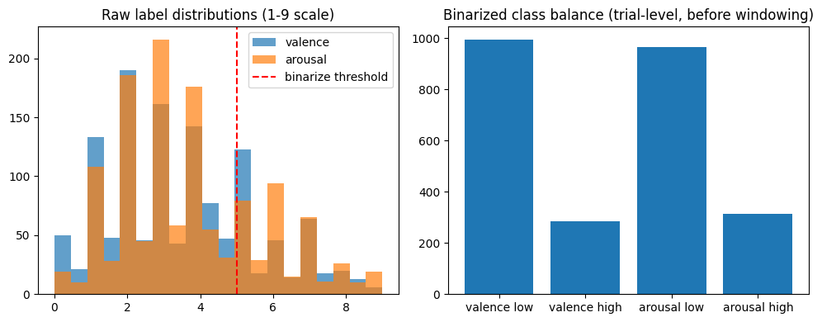
Figure 1. Raw label distributions and binarized class balance (unchanged from the base pipeline).

2.2 Subject-Independent Split
As before, GroupShuffleSplit was used to assign entire subjects (never individual windows) to training (20 subjects, 23,200 windows), validation (5 subjects, 5,800 windows), and test (7 subjects, 8,120 windows), with disjointness asserted in code and normalization statistics computed on training subjects only. This guarantees that the results below reflect genuine subject-independent generalization rather than leakage through repeated or adjacent windows.

2.3 Model: TEDSTGT
The Time-Efficient Dynamic Spatial-Temporal Graph Transformer (TEDSTGT) encodes each electrode's raw window with a small depthwise CNN and its band-power vector with an MLP, fuses the two into a 64-dimensional per-electrode embedding, builds a learned top-k sparse graph over electrodes (biased toward the physical 10-20 layout via a Gaussian spatial prior), propagates information with two graph message-passing layers, and pools electrodes with a learned attention mechanism before separate linear heads for valence and arousal. The model has 49,366 trainable parameters and runs inference in well under half a millisecond per sample on CPU in this run (0.397 ms/sample; see Table 3).
Hyperparameter | Value
Embedding dimension (d_model) | 64
Dynamic graph top-k | 6
Spatial bias weight | 0.3
Graph message-passing layers | 2
Trainable parameters | 49,366
Table 1. TEDSTGT architecture hyperparameters (unchanged from the base model).

3. Training and Test Results
The model was trained for 3 epochs with the same joint, class-weighted, label-smoothed cross-entropy objective, AdamW optimizer, and ReduceLROnPlateau scheduler as before. Validation mean accuracy peaked at Epoch 1 (0.775) and degraded notably by Epoch 3 (mean accuracy fell to 0.662, driven by a sharp drop in valence accuracy to 0.599), so the Epoch-1 checkpoint was restored for evaluation.
Epoch | Train Loss | Val Loss | Val Valence Acc. | Val Arousal Acc. | Val Mean Acc.
1 | 1.3292 | 1.3102 | 0.820 | 0.730 | 0.775 (best)
2 | 1.3127 | 1.3162 | 0.820 | 0.720 | 0.770
3 | 1.2987 | 1.3799 | 0.599 | 0.724 | 0.662
Table 2. Per-epoch training and validation metrics. The Epoch-3 collapse in valence accuracy suggests the short, 3-epoch schedule is not yet stable, echoing the previous iteration's finding that more training is needed before the architecture's true ceiling can be assessed.
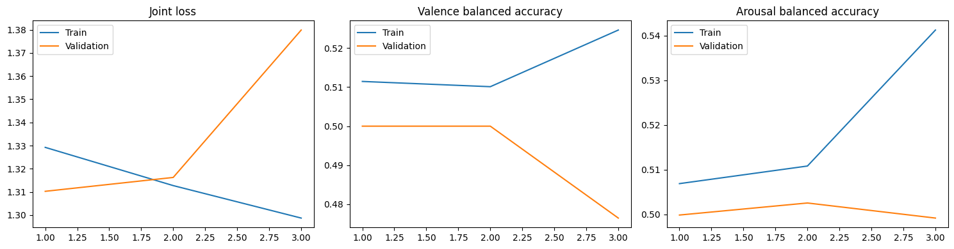
Figure 2. Joint loss and per-task balanced accuracy across training epochs.
On the held-out, subject-independent test set (8,120 windows from 7 unseen subjects), the restored Epoch-1 checkpoint achieved the following:
Task | Class | Precision | Recall | F1-score | Support
Valence | Low | 0.7642 | 0.9997 | 0.8662 | 6,206
Valence | High | 0.0000 | 0.0000 | 0.0000 | 1,914
Arousal | Low | 0.7433 | 0.9997 | 0.8527 | 6,032
Arousal | High | 0.7500 | 0.0029 | 0.0057 | 2,088
Table 3. Per-class precision, recall, and F1-score on the test set.
Metric | Valence | Arousal
Accuracy | 0.7640 | 0.7433
Macro-F1 | 0.4331 | 0.4292
ROC-AUC | 0.5540 | 0.5062
Table 4. Summary test-set metrics.
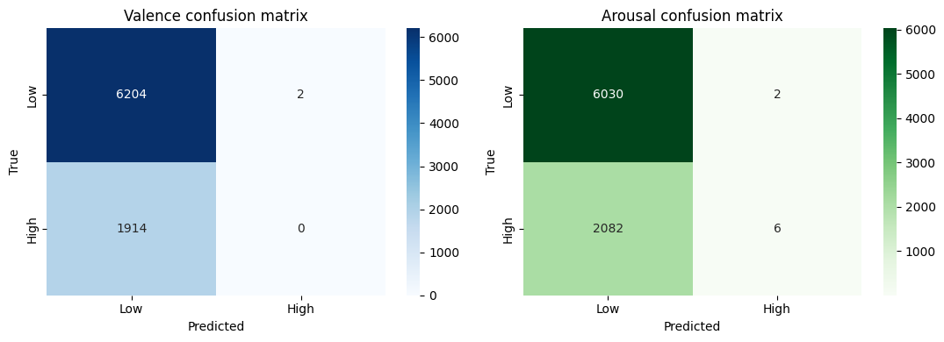
Figure 3. Test-set confusion matrices. Valence predicts “High” zero times out of 1,914 true “High” windows; arousal predicts “High” only 6 times out of 2,088, though those 6 predictions are correct (precision 0.75, recall 0.0029).
As in the previous iteration, raw accuracy (74–76%) is misleadingly close to simply predicting the majority “Low” class for every window, and ROC-AUC close to 0.50 (especially for arousal, 0.506) indicates the model has learned little separable signal. This report's explainability analysis (Sections 4–6) was designed specifically to probe why, and it produces converging evidence for the same conclusion from three independent angles.

4. Explainability I: Aggregated Attention and Learned Graph
The model's electrode-pooling attention weights and dynamic adjacency matrix were averaged over all 8,120 test windows to summarize which electrodes and connections the network relies on “on average.” Figure 4 ranks all 32 electrodes by mean attention weight; Figures 5 and 6 present the same information as a scalp topography and as a network diagram of the strongest 10% of learned edges.
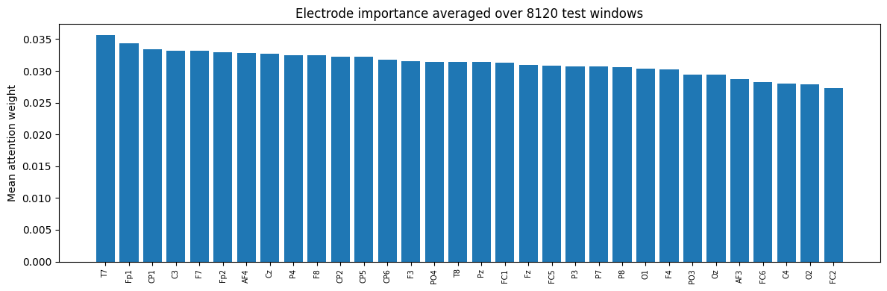
Figure 4. Mean electrode-attention weight, averaged over all 8,120 test windows, ranked from most to least attended (T7, Fp1, CP1 highest; FC2, O2, C4 lowest).
A first observation is that the range of mean attention weights is narrow — from about 0.027 to 0.036 — against a uniform baseline of 1/32 ≈ 0.031. In other words, the attention mechanism distributes weight almost evenly across all electrodes rather than sharply concentrating on a small subset, which is already a mild warning sign for a model that is supposed to have learned which electrodes carry emotion-relevant information.
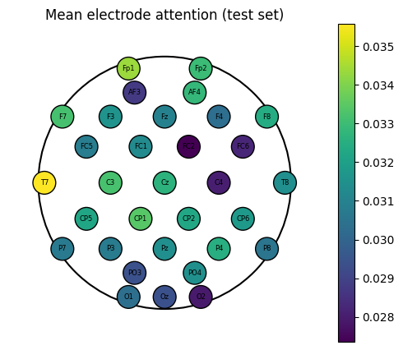
Figure 5. Scalp topography of mean electrode attention. Frontal-temporal electrodes (T7, Fp1) are marginally favored, broadly consistent with regions often implicated in EEG affect literature, but the overall spread across the scalp is small.
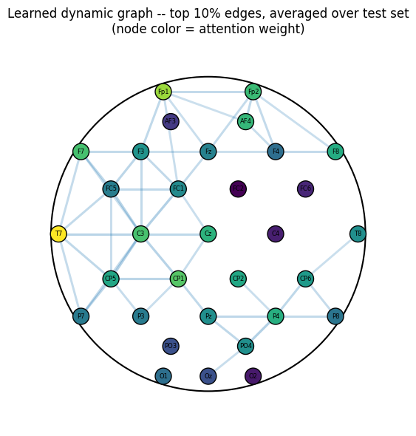
Figure 6. Learned dynamic graph, showing the strongest 10% of edges averaged over the test set (node color = attention weight). The graph favors short-range, spatially local connections — expected given the spatial-prior bias term — rather than revealing a striking long-range functional pattern.

5. Explainability II: Integrated Gradients
Integrated Gradients (IG) accumulates the model's gradient along a straight-line path from an all-zero baseline (which, since inputs are z-scored, represents an “average” rather than a “no-signal” input) to the real input, yielding a signed attribution per input feature that approximately sums to the change in the target logit. Unlike attention, IG attributions are a property of the whole model (all layers), not just the pooling step, so they provide an independent view of what the network is sensitive to.

5.1 Per-Band, Per-Electrode Attribution
IG was computed with respect to each of the four class/head combinations (valence-High, valence-Low, arousal-High, arousal-Low) over a random sample of 300 test windows, and the mean absolute attribution was aggregated per electrode and frequency band (Figure 7).
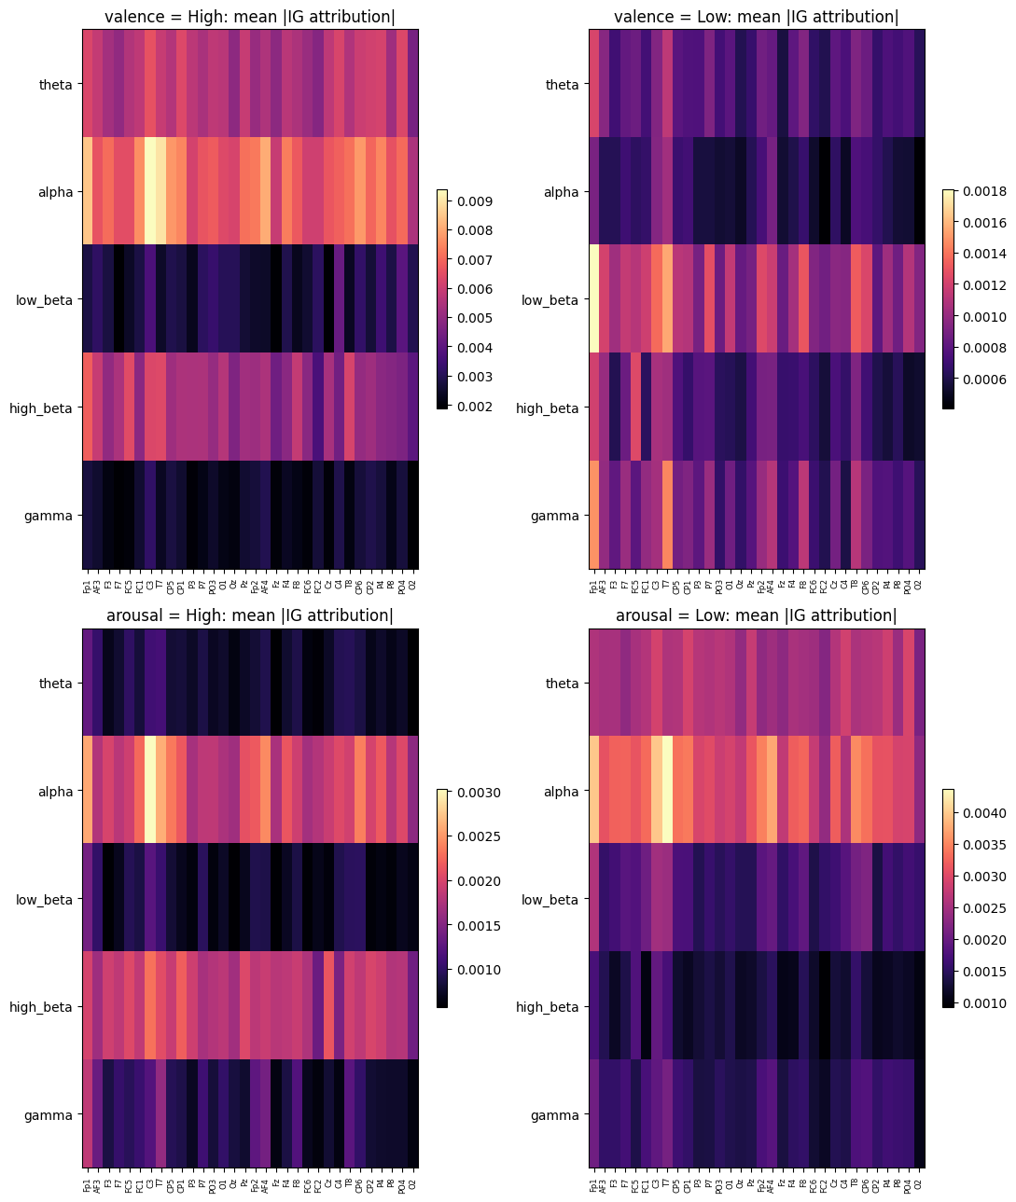
Figure 7. Mean absolute Integrated Gradients attribution, per electrode (x-axis) and frequency band (y-axis), for each of the four class/head combinations. The alpha and low-beta bands dominate across nearly all four panels.
The most informative feature of Figure 7 is not which panel has the highest peaks, but how similar the four panels are to one another: in all four cases (both classes, both tasks) the alpha band and, to a lesser extent, low-beta receive the largest attributions, and the spatial pattern across electrodes is broadly uniform. If the model had learned genuinely class-discriminative features, one would expect the valence-High and valence-Low heatmaps (or arousal-High vs. arousal-Low) to differ noticeably — for example, different bands or electrodes lighting up for each class. Instead, the four heatmaps look like variations on the same underlying pattern, which is consistent with a model whose gradient is dominated by generic input statistics (i.e., which frequency bands simply carry the most variance) rather than by features that separate High from Low.

5.2 Raw-Signal Channel Importance
IG was also computed with respect to the raw time-domain branch for the “High” class of each task, summed over time to obtain a single importance value per electrode (Figure 8).
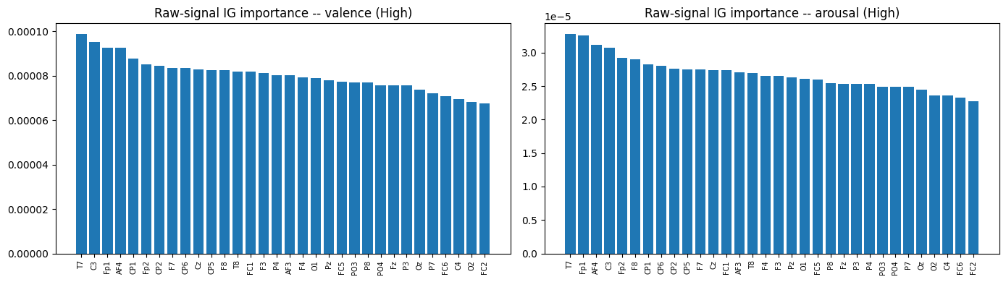
Figure 8. Raw-signal IG channel importance for the “High” class, valence (left) and arousal (right).

6. Explainability III: Permutation Importance
Attention weights and IG attributions are both internal to the model: a network can, in principle, learn to attend to or have high gradient sensitivity toward an electrode without that electrode actually driving its output. Permutation importance answers a more direct question: if the information carried by one electrode is destroyed (by shuffling its values across the batch while leaving every other electrode intact), how much does balanced accuracy on the test set actually drop? Because balanced accuracy is used (rather than raw accuracy), a model that outputs the same class regardless of input would show an importance of essentially zero for every electrode — which is exactly the diagnostic value of this test here.
The baseline balanced accuracy — before any shuffling — was 0.4998 for valence and 0.5013 for arousal, both statistically indistinguishable from the 0.50 expected of a classifier that assigns the majority class regardless of input. Each of the 32 electrodes was then shuffled in turn and the drop in balanced accuracy recorded (Figure 9).
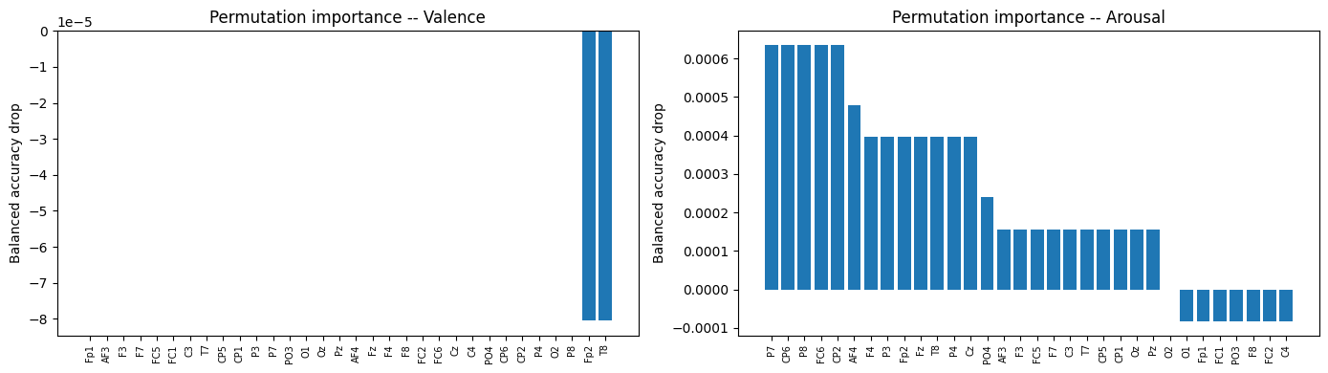
Figure 9. Balanced-accuracy drop when a single electrode's values are shuffled across the batch, for valence (left) and arousal (right). Note the y-axis scales: at most ≈8×10⁻⁵ for valence and ≈6×10⁻⁴ for arousal — both negligible in absolute terms.
The scale of these drops is the key finding: even the single most “important” electrode by this measure changes balanced accuracy by less than 0.1 percentage points for arousal, and by an amount so small for valence that it is barely distinguishable from zero (and in some cases the reported “drop” is negative, i.e. shuffling very slightly increased balanced accuracy, which is only possible when the true effect size is at the level of noise). This is a direct, model-agnostic confirmation that no single electrode's raw signal is meaningfully driving the model's predictions — consistent with a model that has largely learned to predict a near-constant class regardless of input, exactly as Section 3's confusion matrices showed.
For reference, the top-ranked electrodes by this (very small) signal were:
- Valence: Fp2, T8 showed the (negligible) largest measured drops; most other electrodes showed no measurable effect.
- Arousal: P7, CP6, P8, FC6, and CP2 showed the largest (still small, ≈0.0006) drops.

7. Explainability IV: Is Attention a Faithful Explanation?
A natural question is whether the attention weights (Section 4), which are cheap to compute and visually appealing, actually agree with permutation importance (Section 6), which is expensive but grounded in an actual causal intervention. If a model's attention is a faithful explanation of its behavior, electrodes with high attention should also be the electrodes whose removal hurts performance the most — i.e., attention and permutation importance should be positively and significantly correlated across the 32 electrodes.
Spearman's rank correlation between mean attention and permutation-importance drop was computed separately for each task:
Task | Spearman ρ | p-value | Interpretation
Valence | -0.154 | 0.401 | Not significant; slightly negative
Arousal | 0.121 | 0.509 | Not significant; weak positive
Table 5. Spearman correlation between mean attention weight and permutation-importance drop, across all 32 electrodes.
Neither correlation is statistically significant (both p > 0.4), and the valence correlation is even in the “wrong” (negative) direction. This means that, for this trained model, attention weights are not a reliable indicator of which electrodes actually matter for the prediction — the model's attention pattern is essentially decoupled from what a causal ablation test reveals. This is an important and somewhat sobering finding for the interpretability goals of the project: it shows that visualizing attention alone (Section 4), while common practice and visually persuasive, would have given a misleading account of the model's reasoning if not cross-checked against a model-agnostic method like permutation importance.

8. Instance-Level Case Studies
To complement the aggregate analyses above, Integrated Gradients was also applied to individual test windows to see what an explanation looks like for one correctly classified and one misclassified example (valence head).
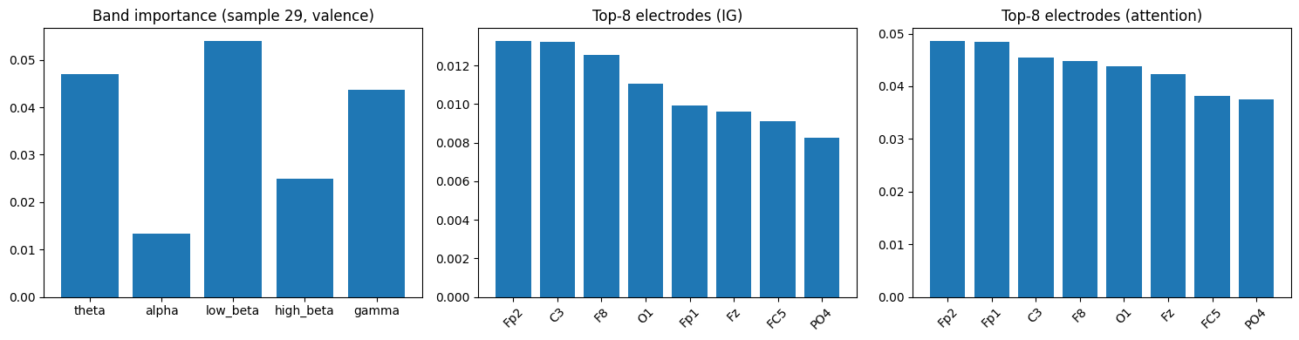
Figure 10. Per-sample explanation for a correctly classified window (true valence: Low, predicted: Low): band importance, top electrodes by IG, and top electrodes by attention.
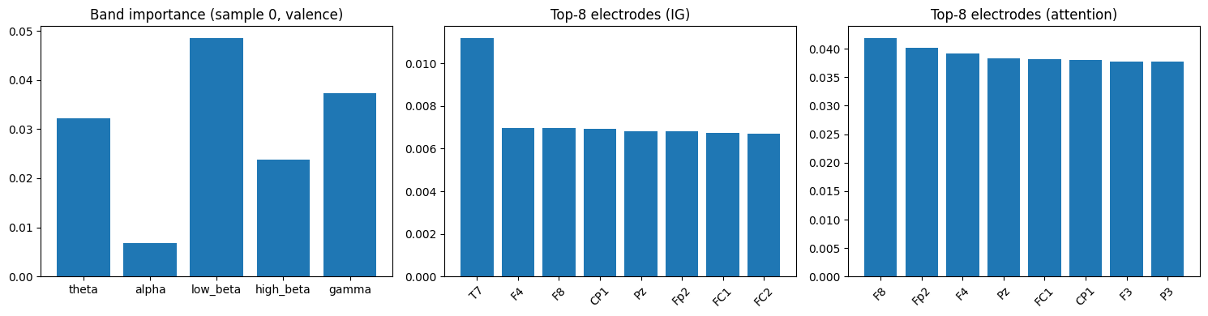
Figure 11. Per-sample explanation for a misclassified window (true valence: High, predicted: Low): the model again defaults to “Low,” and the underlying band/electrode importance profile looks qualitatively similar to the correctly classified example in Figure 10, reinforcing the aggregate finding that the model's internal attributions do not meaningfully differentiate between cases it gets right and cases it gets wrong.

9. Discussion
Considered together, Sections 4–8 substantially deepen the diagnosis first made from the confusion matrices and ROC-AUC scores in Section 3. Four independent lines of evidence — (i) a near-uniform aggregate attention distribution, (ii) IG attribution heatmaps that look alike across opposite classes, (iii) permutation-importance drops that are negligible in absolute size for every electrode, and (iv) a non-significant (and for valence, even negative) correlation between attention and permutation importance — all point in the same direction: the current model has not learned electrode- or band-specific features that causally drive class-discriminative predictions. Rather, it has converged toward outputting close to a fixed class distribution, and its attention/IG patterns mostly reflect generic properties of the EEG signal (such as alpha-band dominance, which is a well-known general property of resting/relaxed EEG rather than something specific to affect) rather than a learned decision boundary.
This is a valuable outcome for a project component whose explicit purpose is interpretability: the suite of tools did its job by revealing a model that superficially looks reasonable (74–76% accuracy) but is not actually doing what it appears to be doing. Critically, this would not have been visible from attention maps or IG heatmaps in isolation — both of those, taken alone, produce plausible-looking scalp maps and band-importance charts that could easily be over-interpreted as “the model has learned that alpha-band activity at frontal-temporal electrodes drives valence.” It is only the permutation-importance ablation test and the explicit faithfulness correlation that expose this as an illusion for the current model.

10. Limitations and Future Work
- The root cause remains the same as identified previously: only 3 training epochs, with the best checkpoint at Epoch 1 and a fall-off (not an improvement) by Epoch 3, indicates the model is under-trained rather than fully converged. Explainability analysis on an under-trained model can only describe what a partially trained network is doing — the same suite should be re-run once training is extended with a proper early-stopping criterion based on macro-F1 or balanced accuracy rather than raw accuracy.
- Class-imbalance handling (softened inverse-frequency weighting, softness 0.5) again appears insufficient; stronger measures (focal loss, minority oversampling, or a tuned decision threshold) should be tried before the explainability suite is expected to reveal genuinely class-specific attributions.
- Permutation importance here shuffles one electrode at a time within a batch (an approximation of a full-dataset shuffle, done for computational efficiency); a full-dataset shuffle or a leave-one-electrode-out retraining would give a more rigorous (if far more expensive) estimate.
- The faithfulness test used only Spearman correlation between attention and permutation importance; complementary faithfulness metrics (e.g., comprehensiveness/sufficiency curves, or correlating IG rather than attention with permutation importance) would triangulate the conclusion further.
- Because IG's baseline is an all-zero (i.e., “average”) input under z-scoring, attributions describe sensitivity relative to the population mean; results might change with a different baseline choice (e.g., per-subject or per-class baselines), which is worth testing once the underlying model itself is improved.
- Once retrained with a stronger schedule, the full explainability suite (Sections 4–8) should be re-run; a genuinely discriminative model would be expected to show sharper, class-differentiated IG heatmaps, larger permutation-importance drops concentrated in fewer electrodes, and a significant positive attention/permutation-importance correlation — all of which can serve as a checklist for whether the next training iteration has actually succeeded.

11. Conclusion
This report added a comprehensive, four-part explainability analysis — aggregated attention/graph visualization, Integrated Gradients, permutation importance, and a quantitative faithfulness check — on top of the group's existing dual-domain graph-based EEG emotion recognition pipeline. Rather than simply illustrating the model's internals, this analysis functioned as a diagnostic tool in its own right: it showed, through several independent and mutually corroborating methods, that the model's currently middling accuracy is driven by a near-constant majority-class prediction rather than genuine electrode- or band-specific discrimination, and that its attention weights in particular are not currently a faithful account of its (very limited) decision process. This is precisely the kind of finding an explainability-focused evaluation is meant to surface, and it gives the project a clear, evidence-based checklist — sharper class-differentiated attributions, larger and more concentrated permutation-importance effects, and a significant attention/importance correlation — against which to judge the next, more thoroughly trained iteration of the model.

